2021 Report of Accomplishments
Central Curry Soil & Water Conservation District

Mission of the Central Curry Soil and Water Conservation District
Conserving and developing the natural resources.

District Wide Projects
- The Central Curry SWCD continues to have a very active windbreak program. Central Curry sells drip supplies, weed barrier, as well as provides technical assistance to cooperators in the district.
- Central Curry continues to care for the living snow fence that we installed in April 2008. This project is located on the north side of NM 241, located 5 miles east of Broadview, NM. This area creates a considerable challenge for motorists as well as state highway personnel during the winter months when blowing snow results in highway closure. The goal of this endeavor is to protect the highway from blowing snow and to save taxpayers’ dollars when the State Highway Department no longer has to remove snow.
- Central Curry is offering the producers of the area an opportunity to restore playas in the area with a Playa Restoration Cost Share Program. The program assists producers in filling in pits, channel remediation, silt removal and more.
- Central Curry is offering a Rain Water Harvesting Cost-share to its producers. The cost-share assists producers in conserving water and using channeling our natural resources for the greater good.
- Central Curry is also assisting in other water conservation efforts by offering a Shade Ball Cost-Share. Through this cost-share producers have been able to cut done on water evaporation and usage.

Information/Education
- Central Curry SWCD sponsored education contests through FFA and 4-H. Other events sponsored were Prairie Partners, Envirothon and High Plains Coop. Weed Management.
- Central Curry helped sponsor the Farm Bureau Legislative Event.
- Erik attended multiple meetings concerning Noxious Weed Training..
- Meetings that the supervisors attended or did presentations at include:

  - NMSU Ag Field Day
  - District Annual Meeting
  - NMACD Meeting
  - Playa Lake Joint Venture
  - Prairie Partners
  - Water Policy Advisory Board
  - El Llano Estacado RC&D
  - Water Policy Trust

Interaction and Networking Efforts
- The board members have a wide variety of experience and education in the area of conservation of natural resources. From actual hands on experience from their own land practices to their job duties at the State Land Office and the NMSU Ag Experiment Station in Clovis. This relationship has allowed the current and upcoming needs of local producers to be better addressed.

District Wide Projects
- The Central Curry SWCD continues to have a very active windbreak program. Central Curry sells drip supplies, weed barrier, as well as provides technical assistance to cooperators in the district.
- Central Curry continues to care for the living snow fence that we installed in April 2008. This project is located on the north side of NM 241, located 5 miles east of Broadview, NM. This area creates a considerable challenge for motorists as well as state highway personnel during the winter months when blowing snow results in highway closure. The goal of this endeavor is to protect the highway from blowing snow and to save taxpayers’ dollars when the State Highway Department no longer has to remove snow.
- Central Curry is offering the producers of the area an opportunity to restore playas in the area with a Playa Restoration Cost Share Program. The program assists producers in filling in pits, channel remediation, silt removal and more.
- Central Curry is offering a Rain Water Harvesting Cost-share to its producers. The cost-share assists producers in conserving water and using channeling our natural resources for the greater good.
- Central Curry is also assisting in other water conservation efforts by offering a Shade Ball Cost-Share. Through this cost-share producers have been able to cut done on water evaporation and usage.

New Mexico Conservation Districts
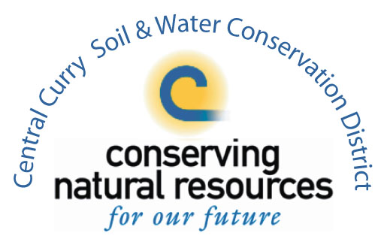
Assisting land managers with their conservation choices.

