Western Mora Soil & Water Conservation District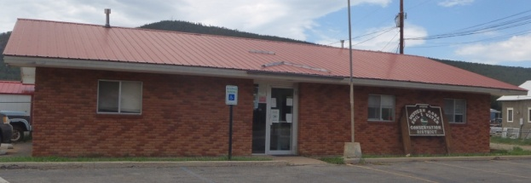

2022-2023 Report of Accomplishments

Western Mora SWCD Board of Supervisors and Staff operate all conservation programs under the principles of transparency, integrity, and accountability. We believe that this is essential in order to maintain public trust.

Program Summary

Acequia Assistance Cost-Share Program
- Program still active, however no applicants this year

Equipment
- The district currently owns a John Deer tractor, discs, plow, skid-steer, chipper, no till drill, reg-drill, auger, brush hog, ditcher, broadcaster/fertilizer spreader and rotary tiller. The district rents out the equipment assisting producers with prepping fields, planting, and everyday ranching.
- The district rents out the equipment assisting producers with prepping fields, planting, and everyday farming/ranching.
- Through Capital Outlay, the district purchased a 420 07A CAT Backhoe Loader that will be rented out for larger/acequia projects.
- A two-wheel tractor was purchased as well as a rear tire triller to assist smaller projects/gardens.

Federal & State Funding
- Western Mora SWCD received approximately $19,167 from State sources.
- Capital Outlay Funding FY22/23 $225,000-purchased backhoe & utility truck
- Lease agreement for NRCS $66,420/annual for 10-year lease

Local Funding
- The Western Mora SWCD received approximately $85,000+ Mill Levy income

Working with the Community
- Co-sponsorship Emergency Watershed Protection Program (EWP) Hermit’s Peak/Calf Canyon Fire
- Mora/San Miguel Long Term Recovey Group-Hermit’s Peak/Calf Canyon Fire
- Collaboration with all state/federal/local/private entitis regarding Hermit’s Peak/Calf Canyon Fire
- Envirothon Regional participation w/ Mora High School students/sponsorship for State competition
- Healthy Soil Sponsorship for individual project
- Collaboration with NM State Forestry issuing wood permits

