|  |
| --- |
| Southwest Quay  Soil & Water Conservation District |
| 1304 CR AB, Melrose, NM 88124 |

*2022-2023 Report of Activites*

*Board and Mission* Southwest Quay Soil and Water Conservation works with producers in the area to safeguard and enhance soils in our district. We are committed to promoting soil health through outreach, research, and support to our local producers. We encourage and educate current farmers and ranchers as well as up-coming farmers and ranchers about the many ways to preserve the land.

We also work with the producers to improve and protect our water resources. We advise land owners on nutrient management strategies and erosion prevention practices. We make sure land owners have the proper tools they need to protect water from sediment runoff, nutrients and other contaminants. With our area being in a drought, we work with stakeholders in managing water quantity to help ensure a sufficient supply exists to meet a variety of needs. We work to prevent and mitigate the effects of drought.

We take great pride in our land and the resources in it. We love to work with the producers in helping them get the most they can out of their land and water. We do the best we can to meet the needs of all the producers and encourage them to reach out to us to let us know what we can do for them.

Your District Board Members include:  
 Chairman-Lisa Runyan Supervisor-Jovani Armendariz  
 Vice Chair- Kole Tatum Supervisor- Kandy Hutchins  
 Sec/trea- Clyde Moon Supervisor - Bobby Lee  
Supervisor – Sean Reagan District Manager – Lynnae Abarca

*Funding* SW Quay SWCD receives a majority of their funding from the state legislation using the Point System. As a District we also received partial funding through a water quality grant to be able to conduct our ground water monitoring project. We also funding through the Healthy Soils Grant to be able to help some producers conduct soil samples on their land. We got the pleasure as well of working with the Playa Lake Restoration as well to get some additional funding for this. We also work with other districts in the state and Zeigler Geologic Consulting to be able to support the 4-H and the FFA in their Judging achievements related to Soil and Water Conservation.

*Education* Each of our board members have all taken time to attend many educational meetings and workshops. Some of these include NMACD and NACD meetings, Healthy Soil Trainings, and CEU Classes. We have continued sending out our quarterly newsletter to share our knowledge gained with all of our producers. We were excited to be able to sponsor many events to further Soil and Water conservation including the NMACD regional meeting, Outdoor Classroom, and the NM Envirothon. We have also had the opportunity to sponsor some of our local 4-H kids in being a sponsor for the Quay County 4-H Rodeo.

*Conservation Projects* Groundwater Hydrology Study as many of you know, Southwest Quay SWCD launched a long-term groundwater monitoring project at the beginning of 2017. In partnership with a team of geologists with Zeigler Geologic Consulting, the SWCD is seeking to gather data to help us all understand the groundwater resources our producers rely on. We’ve learned quite a lot in the last four years, but we still have a ways to go to fully understand the aquifers in the area. The data that we are gathering includes static water level measurements, water chemistry, and tritium isotopes. Each August and each February, the geology team comes through to check the depth to water in the 35+ wells that are part of the monitoring network.

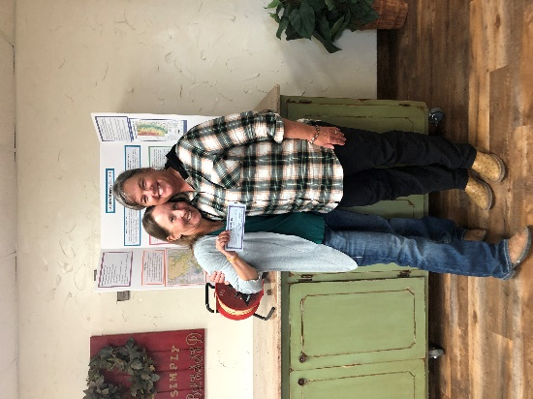  
 South West Quay Soil and Water Conservation likes to offer a few cost-share programs to our producers. The two that we currently offer are Shade Balls and Brush Control. In both of these programs we will pay for a portion of the total cost of purchasing brush control or shade balls.  
 We have been given the privilege this year of receiving a Healthy Soil Grant for the district. Through this grant we have been able to work with producers to test their soil and do an infield soil assessment. This grant has given us a good view of the soil quality of the land and what we need to do as a district to support our producers in the future.

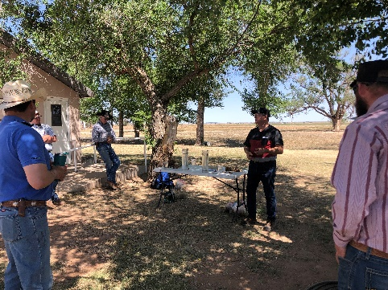 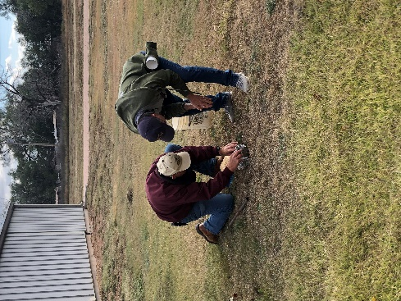 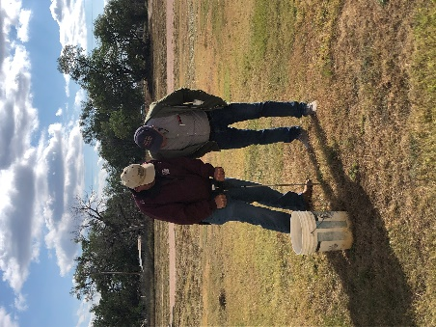  
 We are also excited to be able to offer Playa Lake Restoration in this year. Playas provide many benefits to people and wildlife including groundwater recharge, water filtration, erosion and flood control, and upland game bird hunting and wildlife viewing opportunities.

*Voice of Conservation* Many of our board members have been given the opportunity to speak and participate in different webinars and workshops. Some of these include the Field Days we have hosted, 30 by 30 RFI, and SWCD Annual Meeting.

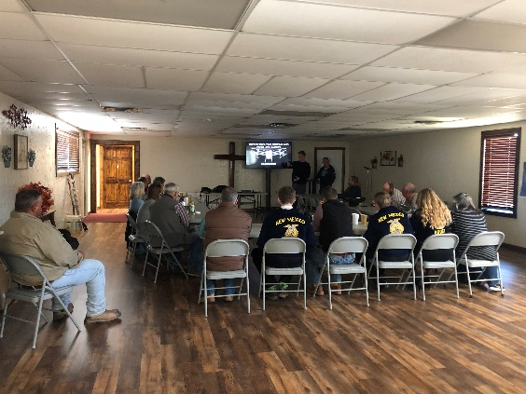 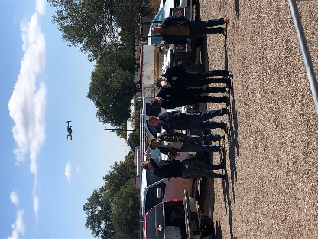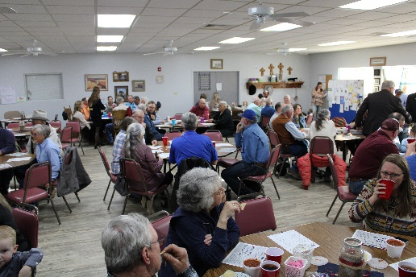

In conjunction with the NACD we also hosted our annual Poster Contest. This was for all age group within our district (adult to kindergarten). We were able to educate all of the participates about healthy soils = healthy life through this contest. Below are pictures of the winning posters for this years contest.

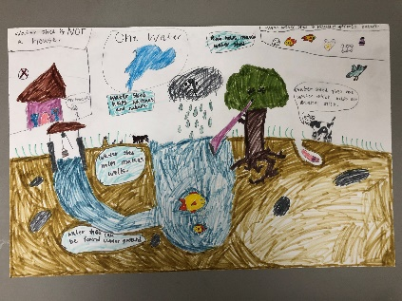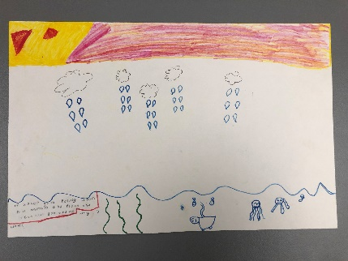 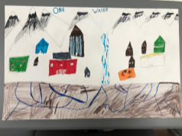

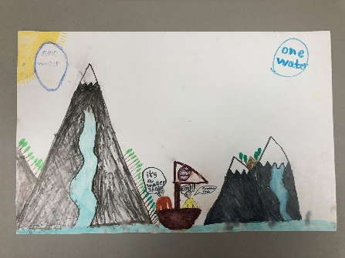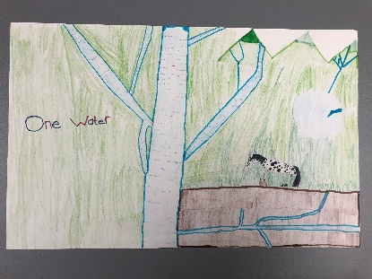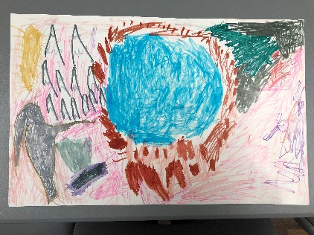

*Awards* We work yearly with other districts in the state to be able to award kids that participate in FFA and 4-H judging contests. These contest this year include land, range, agronomy, homesite, and forestry. Through help form other districts we were able to fund the first place team as well as the first second and third place individuals in these contests. We would also to send a special to congratulations to Seth Dunlap and Kymber Casados from Estancia FFA for their high accomplishments!

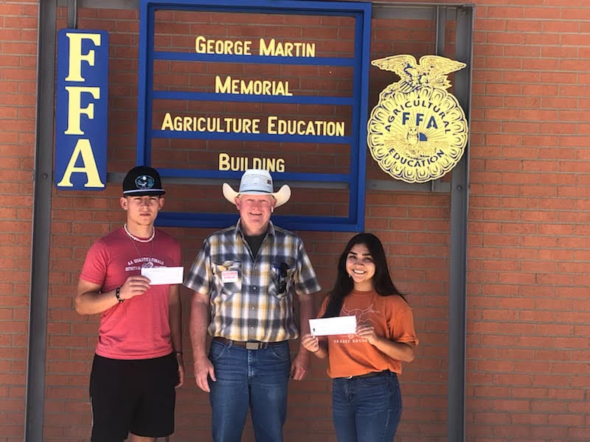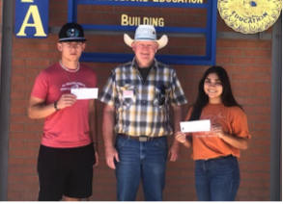

We were happy to award Tom Sidwell for his many years of service to Soil and Water Conservation. We appreciate him serving as a District Supervisor for more than 10 years and continue to support the district in many ways! Thanks again for all you do!

